Project Design Phase
Solution Architecture

Date | 30 September 2026
Team ID | SWTID-2026-1691
Project Name | AI BlogNest API
Maximum Marks | 4 Marks

Solution Architecture:
Solution architecture is a complex process – with many sub-processes – that bridges the gap between business problems and technology solutions. Its goals are to:
- Find the best tech solution to solve existing business problems.
- Describe the structure, characteristics, behavior, and other aspects of the software to project stakeholders.
- Define features, development phases, and solution requirements.
- Provide specifications according to which the solution is defined, managed, and delivered.

Solution Architecture Diagram – AI BlogNest API:

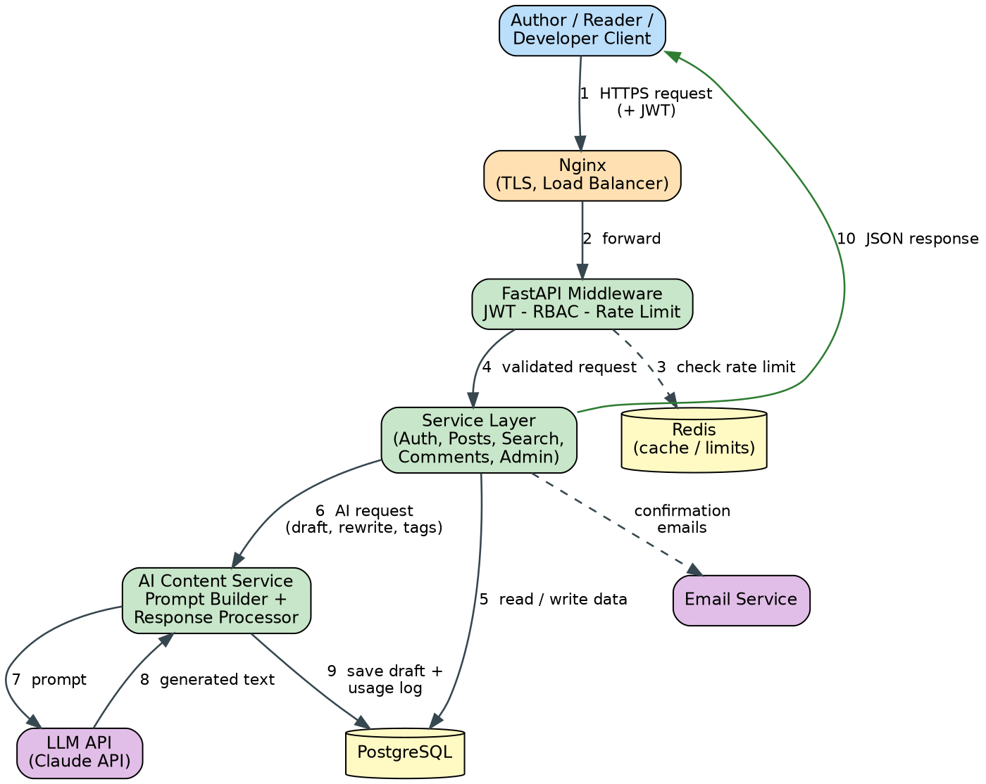
Figure 1: Architecture and data flow of AI BlogNest API
Architecture flow:
1. A client (web app, mobile app or Swagger / Postman) sends an HTTPS request, with a JWT for protected endpoints.
2. Nginx terminates TLS and load-balances the request to a FastAPI container.
3. Middleware checks the rate limit (Redis counters), validates the JWT and applies role-based access.
4. The validated request reaches the service layer (auth, posts, search, comments, admin).
5. The service layer reads and writes data in PostgreSQL; confirmation emails go out through the email service.
6. For AI features, the AI Content Service builds a prompt from the user's topic or text.
7-8. The prompt is sent to the LLM API and the generated text is returned and post-processed.
9. The result is saved as an editable draft in PostgreSQL and the AI usage is logged.
10. The API returns a JSON response to the client.

